Mason Core Notes

Introductions

Communication will come through teams in the future. Please turn on notifications for the General channel in the 20-21 teams

Course reviews
INTS 363 Social Justice Narratives
Comments from the survey
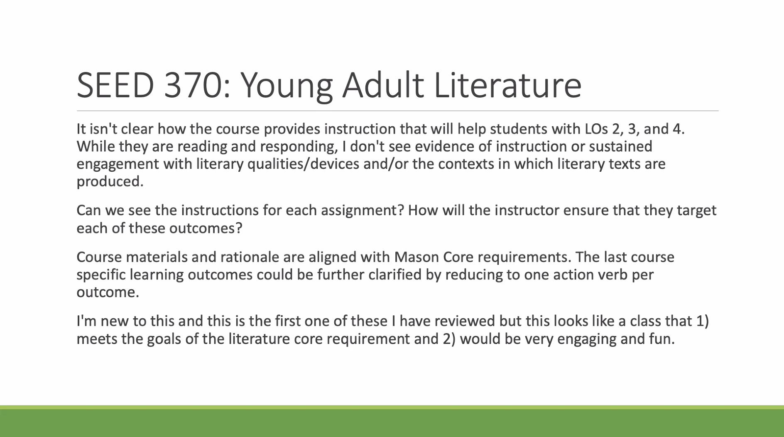

Kelly Dunn responded to the above questions

Comments from the committee:
Submitting faculty did a good job showing changes from the last submission and addressing the outcomes.
The flipping of the emphasis of the course from Social Justice to Literature was a positive change for the proposal
Thought the project might be out reach for the students
Some of the assignments map to different objectives than listed

Voting Results
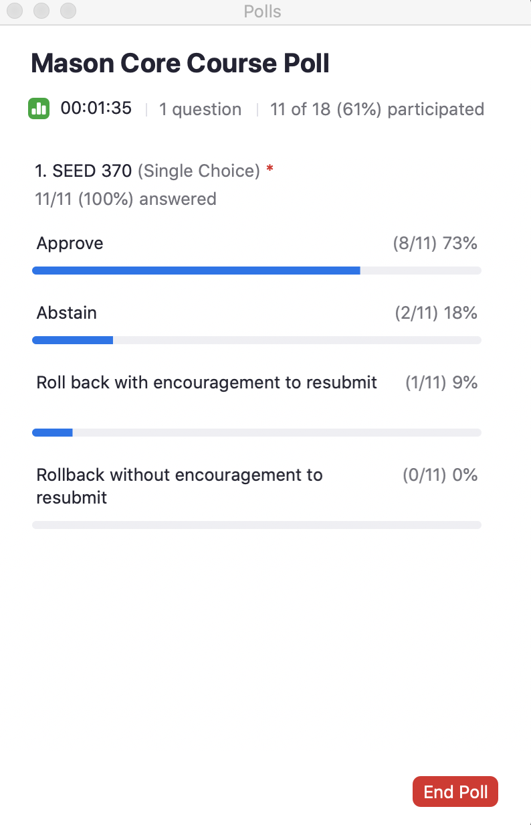

Assessment Presentation given by Gina Polychronopoulus
Discussion about the prestation followed
Topics included
Faculty participation in the rating process
Discussion of syllabus review
Discussion of timing and length of the assessment cycle
Results of the assessments
Making a clear distinction between Mason Core program assessment and course assessment

